RoboQuess

Process Name: ID – XYZ - Calculate Client Security Hash – Loader – p1
ID – XYZ - Calculate Client Security Hash – Worker – p2
ID – XYZ - Calculate Client Security Hash – Reporter – p3
ID Number: XYZ

Version | 1.0
Reviewed By | Ammar Rabbani

Document Information

Version History
Date | Version | Author | Description
 | 1.0 |  | Initial draft

Revision History
Date | Version | Author | Description

Approval
Role | Name | Email Address | Sign-off Date
Process Owner
Process SME
RPA Lead

Contents
Document Information 2
1. Overview 5
1.1 Business Process Description 5
1.2 TO-BE 5
1.3 Robotic Resource Requirement 6
1.4 Environment, Underlying Applications & Installation Details 6
1.4.1 Development 6
1.4.2 UAT 6
1.4.3 Production 6
1.4.4 Production Machine Details 7
1.4.5 Production Justification 7
1.5 Roles and Responsibilities 7
2. Solution Overview 7
2.1 Solution Description 7
2.2 Solution Diagram(s) 8
3. Exceptions & Alerts 9
3.1 Exceptions 9
3.2 Email Alert Recipients 9
4. Process Reports 9
4.1 Process Summary Report: 9
4.2 Exception Report 10
5. Process Design & Object Design 10
5.1 Process Design 10
5.1.1 P1 – Loader………………………………………………10
5.1.2 p2 – Worker…………………………………………….11
5.1.3 P3 - Reporter…………………………………………………………………………………………………………………………………………11
5.2 Object Design 12
6. Operational Control 12
6.1 Scheduling 12
7. Data and Credentials 13
7.1 Data Storage 13
7.2 Work Queues 13
7.3 Data Privacy 13
7.4 Data Preservation 13
7.5 Environment Variables 13
7.6 Session Variables 14
7.7 Credentials 14
7.7.1 Windows 14
7.7.2 Applications 14
7.7.3 Work Queue Encryption Key 14
8. Appendix 14
8.1 Reference Documents 14
8.2 Glossary of Terms / Abbreviations 14
8.3 Solution Design Principles 15

Overview

Business Process Description
The Objective of the process is to Review accounts opening opportunities. Validating the documents and the details in documents for each opportunity and match it with the details in Siebel.
The business objectives and benefits expected by the Business Process Owner after automation of the selected business process are:
- Reduce processing time per item by 80 %
- Better Monitoring of the overall activity by using the logs provided by the robots.

TO-BE

TO-BE Process:
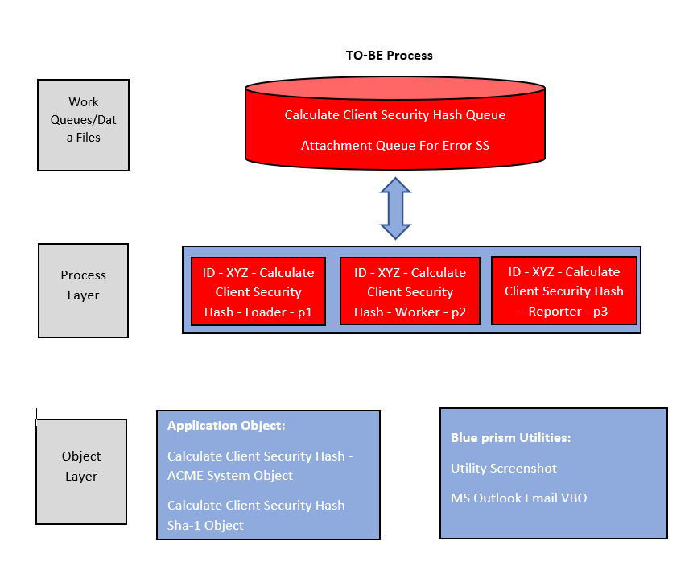

TO-BE Process

Robotic Resource Requirement
Current process key workload requirements & SLA
Current frequency of process execution
Number of transactions processed
Current average process time

Automated Process Estimation
Estimated average scheduled run time for the automated process | ~6-10 mins
Each robot would process an estimated | N/A
Estimated number of robots proposed | 1

Environment, Underlying Applications & Installation Details
    - Development
Application Name | Application Type | App URL/ Location | App Owner Contact Details | Access Required for ID Name | Functional User | Granted  User  Access
MS Outlook | Windows Application | N/A | Microsoft | N/A | NA | NA
ACME System | Web Application | https://acm- test.uipath.com/ | N//A | DEV_RobotID | NA | Yes
Sha1-online | Web Application | http://www.sha1-online.com/ | N/A | DEV_RobotID | N/A | Yes

    - UAT
Application Name | Application Type | App URL/ Location | App Owner Contact Details | Access Required for ID Name | Functional User | Granted  User  Access
MS Outlook | Windows Application | N/A | Microsoft | N/A | NA | NA
ACME System | Web Application | https://acm- test.uipath.com/ | N//A | UAT_RobotID | NA | Yes
Sha1-online | Web Application | http://www.sha1-online.com/ | N/A | UAT_RobotID | N/A | Yes

    - Production

Application Name | Application Type | App URL/ Location | App Owner Contact Details | Access Required for ID Name | Functional User | Granted  User  Access
MS Outlook | Windows Application | N/A | Microsoft | N/A | NA | NA
ACME System | Web Application | https://acm- test.uipath.com/ | N//A | PROD_RobotID | NA | Yes
Sha1-online | Web Application | http://www.sha1-online.com/ | N/A | PROD_RobotID | N/A | Yes

    - Production Machine Details
Host Name | IP | Functional Account | User Access
TBD | TBD | TBD | TBD

    - Production Justification
If SIT/UAT application(s) is/are unavailable for BP Development/UAT, please provide here, clear, and unambiguous knowledge that the following is true:
- Application owner was contacted and is aware of the process being built.
- Business have confirmed there is no test data available.
- Application owner has confirmed in writing that test region is not available.
- SME full time support has been guaranteed for project lifecycle and no development will occur without SME oversight.
Please attach the approvals for the above justifications here - N/A

Roles and Responsibilities
Role | Name | Email | Mobile
Project Manager
Business Analyst
Configurator
RPA Lead
Business SPOC

  - Assumptions
Assumption | Impact of assumption providing to be false
No technical challenges with respect to Product/ Process during implementation | Total time required for building solution would be extended
Developer availability | Total time required for development would be extended
No Application environment issues while developing solutions | Total time required for building solution would be extended

Solution Overview

Solution Description
The solution comprises of the following processes configured in Blue Prism:
Calculate Client Security Hash is a part of small project where objective of this process is to is to take the work items from Acme site calculate its hash from the sha1-online then comment it down with hash and mark the status as complete. It mainly automates the process in loop till all WI5 type item is covered in the table.
Automation solution performs the below actions in Blue Prism:
- Environment Check: The robot will do environment check and if environment is Ok, robot will process further otherwise notify production support and business team with the exception.
- The process will validate apps conditions to check if it should continue running or stop.
- Initialize and Start-up: The robot will run the applications get values and store them in work queue then process it one by one.

- P1 Loader: Calculate Client Security Hash – Loader – p1 process loads the data Item from the table on the website “acme-test.uipath.com” and loads the specific data items with WI5 type, into the work queue named “Calculate Client Security Hash Queue”.

- P2 Worker: Calculate Client Security Hash – Worker – p2 process takes the value from the queue and then searches for the WI5 item on the website “Calculate Client Security Hash Queue”, takes its detail and at the same time calculate its hash value from the website “sha1-online.com” and paste the value of hash as comment, mark it as complete for each data items.

- P3 Report: Calculate Client Security Hash – Reporter – p3 process reports the any unwanted or undesired exception/error with the attached screenshot of the stage that is causing the problem to the production team.

Solution Diagram(s)
Calculate Client Security Hash – Loader – p1

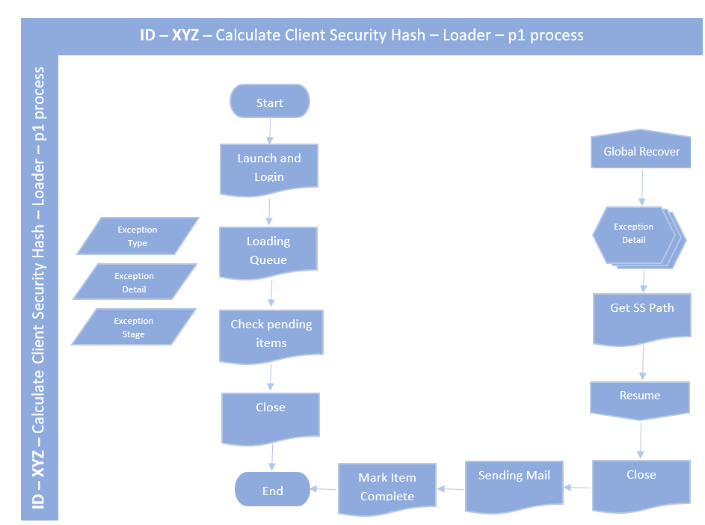

Calculate Client Security Hash – Worker – p2

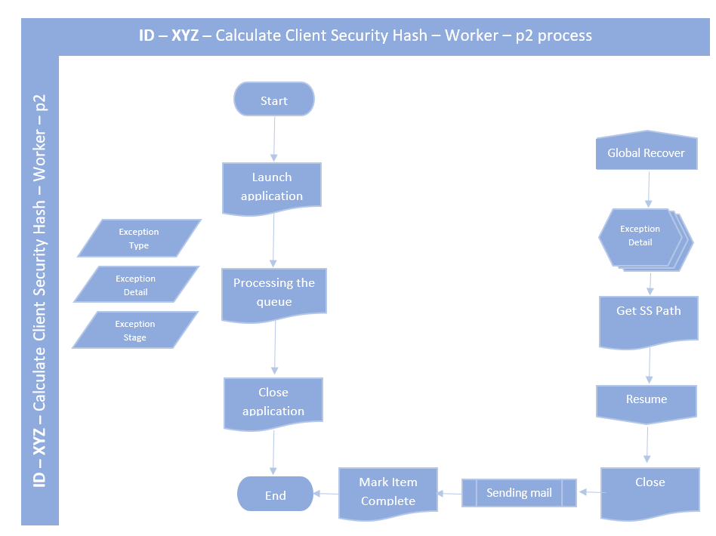

Calculate Client Security Hash – Reporter – p3 process
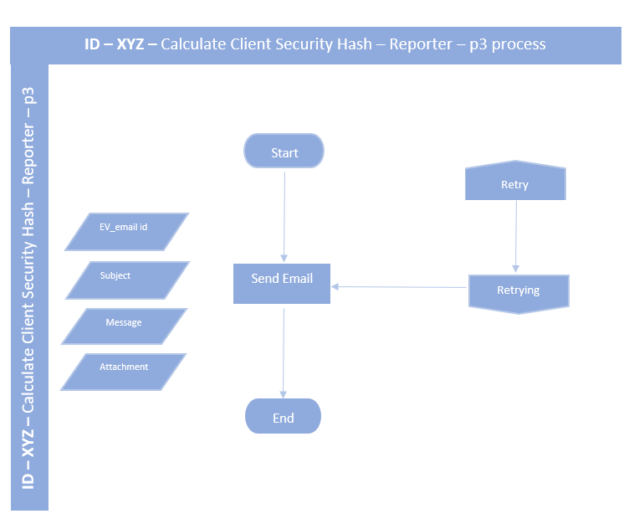

Exceptions & Alerts

Exceptions
Process Step/Scenario | Exception Type (Business / System Exception) | Exception Description | Alert / Notification Mechanism | Severity
Launch and Login Application | System Exception | SE: Unable to Launch and login Application. | Email | HIGH
System down /not responding | System Exception | SE: ACME System/ Sha1-Online applications is not responding. | Email | HIGH
systems are down / not responding. | Business Exception | BE: systems are down or not responding. | Email | MEDIUM

Email Alert Recipients
Email Group | Method | Configuration Name | Recipient(s)
HIGH Severity Email Group | Email | TBD | yasarmirza022002@gmail.com
MEDIUM Severity Email Group | Email | TBD | yasarmirza022002@gmail.com

Process Reports

Process Summary Report:
What is the Notification Mechanism: Email?
Frequency of Notification: All over the week – within any time including all the processed opportunity numbers (completed and exception cases).
Process Summary report to be created and sent to the following distribution list:

Exception Report
What is notification mechanism: For each item, BOT will send the exception details via email and all the items processed within a day will be sent in summary report.
Frequency of Notification: All exceptions will be notified via exception emails.

Process Design & Object Design

Process Design
Process Name  (As per best practices) | Process Type  (Main/ Generic Sub/ Focused Sub process) | Process Group  (Folder in which the process is Grouped) | Needs publishing to Control Room?  (Yes/ No)
Review Account Opportunities - P1 - Loader | Loader Process | Loads Data Items | Yes
Review Account Opportunities - P2 - Worker | Main Process | Performs the Action
Review Account Opportunities - P3 - Reporting | Reporting Process | Review and report | No

5.1.1 Calculate Client Security Hash – Loader – p1
This process will perform the following actions:
a. Launch the chrome and navigate the site on it.
b. Read the Work Item one by one from the table of work items.
c. Loads the data into the queue in the same format.
d. Queue data is used for further processing.

5.1.2 Calculate Client Security Hash – Worker – p2
The process consists of the following work steps:
a. Launch the chrome and navigate the site on it.
b. Searches the data items and reads its values.
c. Navigate the sha-1 site and calculate the hash value and read it.
d. Write the hash as comment and mark item status as completed for each queue items.
e. Repeats this process till the queue is empty.

5.1.3 Calculate Client Security Hash – Reporter – p3
The process consists of the following work steps:
a. Firstly take the screenshot of the stage if needed.
b. Sends the mail to the given email id with information and attached SS if present.

5.2 Object Design
This is the linked Object Design Instructions document created.

Operational Control

Scheduling
The process will run all the week days.
Calculate Client Security Hash – Loader – p1 process
Sunday | Monday | Tuesday | Wednesday | Thursday | Friday | Saturday

Calculate Client Security Hash – Worker – p2 process
Sunday | Monday | Tuesday | Wednesday | Thursday | Friday | Saturday

Calculate Client Security Hash – Reporter – p3 process
Sunday | Monday | Tuesday | Wednesday | Thursday | Friday | Saturday

Application downtimes/maintenance hours below, to be aware of impact on scheduling.
Application Name | Frequency of Downtime/ Maintenance hours | Start time | End time | No. of hrs.
Outlook | N/A | N/A | N/A | N/A
ACME System | N/A | N/A | N/A | N/A
Sha1-Online | N/A | N/A | N/A | N/A

Data and Credentials

Data Storage
DEV: D:\BP Assignment
UAT: D:\BP Assignment
PROD: D:\BP Assignment

For PENDING, COMPLETED and MI: ROBOT will have RW and Business will have RO access.

Work Queues
Work Queue Name | Key Name | Attempts
Calculate Client Security Hash Queue | Column2 | 1
Attachment Queue for Error SS | Attachment | 1
If the key value is RESTRICTED/ HIGHLY RESTRICTED data, then it should be masked to ensure it is not identifiable from control room.

Data Privacy
All customer data held in Blue Prism will be stored encrypted in the Blue Prism work queue. All the Work Queue items visible in the Control Room is encrypted using 256 - Bit Encryption Scheme.
Stage logging across process will be set to Log Errors only and across loops it will be set to Disabled.
Parameters will be disabled to ensure data is not stored in session logs.

Data Preservation
Work data items (Completed and Exception) will be automatically preserved as per Riyad Bank Data Retention policy. Work items MUST not be deleted by the process.
The project team is responsible for Input data files to be purged after relevant number of days.
The project team will take responsibility for the manual purging of aged exception files.

Environment Variables
Detail any environment variables used in the solutions. Only Internal classified data MUST be used in Environment Variables
Environment Variable | Description
EV_email id | This variable contains all process related details

Session Variables
Details any variables which may be viewed and optionally set within Control Room at runtime. Only Internal classified data MUST be used in Session Variables.
Session Variable | Description
Session - Stop After Items | This will store the threshold count of cases for the session.
Session - Stop After Time | This variable will determine what time the instance will run.

Credentials
    - Windows
Access to Windows will be via standard robot credentials for that runtime resource, using Login Agent

    - Applications
Application Name | Credential Store Name | Password Reset Process Name | New Password Policy | Password Reset Tie Interval
ACME System | ID – XYZ - [DESKTOP-OU1KABJ] – ACME System | N/A | Length, special character, number etc. | 3-4 Months
Sha1-Online | ID – XYZ - [DESKTOP-OU1KABJ] – Sha1-Online | N/A | Length, special character, number etc. | 3-4 Months

    - Work Queue Encryption Key
Work Queue Encryption Key Credential store name: N/A
Only one encryption key credential store per ID to be created

Appendix

Reference Documents
Credit Lens Portal Integration PDD shared by business was being referred during the creation of SDD. Refer the link below to view PDD.

Glossary of Terms / Abbreviations
Terms/ Abbreviation | Description
System Exception | These exceptions are related to the underlying application & related infrastructure, therefore, will be marked as an exception in WQ with specific exception details assigned.
Business Exception | As a result of any unexpected input data value or unknown/unhandled process path, these exceptions will be marked as an exception in the work queue with specific exception details assigned.
Business Referral / Business Rule Exception | As a result of failure which requires human intervention. These exceptions will be marked as complete, in the work queue, with specific exception message tagged.

Solution Design Principles
Best Practice | Description
Automate the existing human activities without business solution engineering | - Solutions should allow business to continue the work when certain steps or even the whole client-side automation is not in place to control the risk of automation failure under certain conditions.  (Example. Ad-hoc changes in underlying applications)  - Stay as a tool-the solution is to perform the existing business activities at a faster speed via automation, following the existing business use cases.
Allow human to make decisional activities | - Activities require human judgment, such as transaction submission, approval, certain type of result acknowledgement, etc. should not be automated.  - Human (i.e., The operator) to take responsibility of decisional activities
Avoid system-to-system automation pattern | - Avoid creating risk on systems indefinite loop.  - Activities conducted in extra-ordinary speed may have performance impact to underlying application, which is not under their original design.
Controlled involvement of third party/ external application in automated solution design | - Dar.ME does not have any control of the changes in the third party and externally hosted application. Uncontrolled change will affect the successful execution of the automated solution
Use of conceptual or Field level help | - Keep contextual helps as short, descriptive explanation that can be read quickly.
Use of Automation Toolbar | - Desktop docking toolbar to be used in automation only when something must be shown always.  - Make sure that it occupies as less space as possible within auto hide function, for user to be able to hide it when not required
Screen Construction | - Screen construction should only be considered with business justification.  - Client-side automation should not be used to develop new screens that extend application functionality beyond purpose of automaton

